1. Create and Configure an Azure SQL Database:

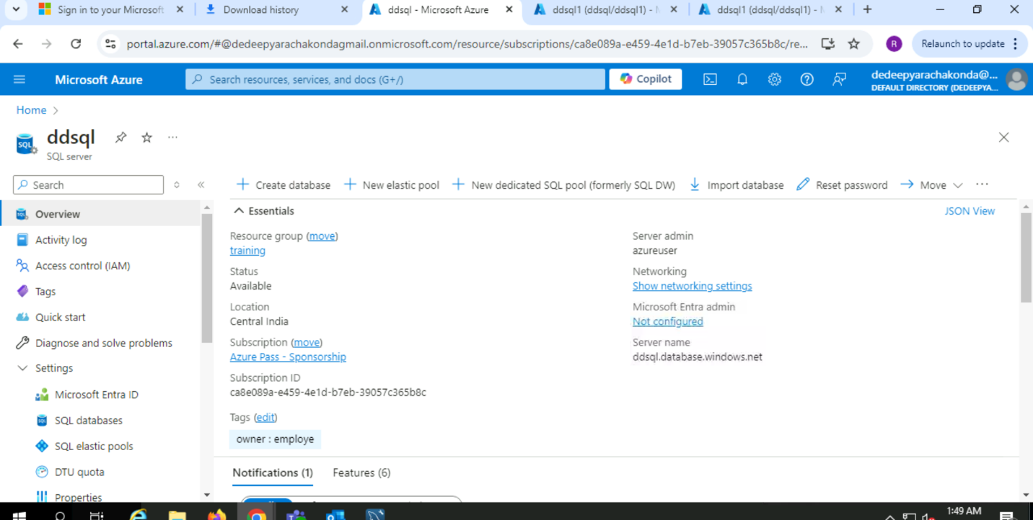

2) Create and Configure an Azure MYSQL Database:

.

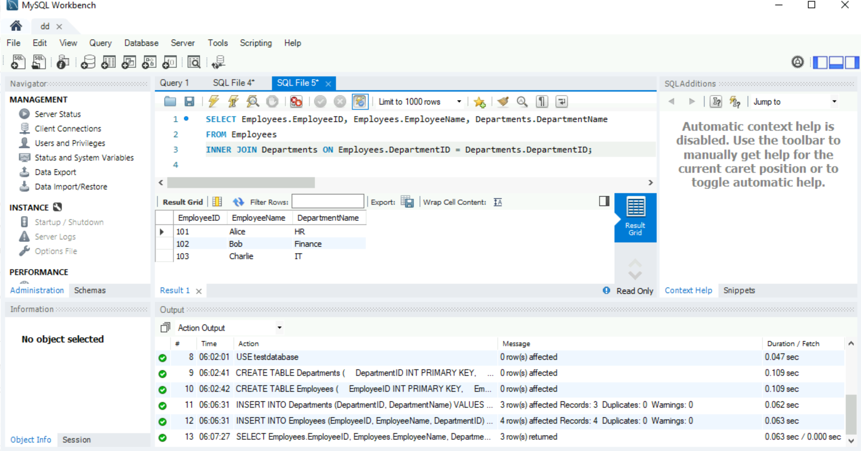

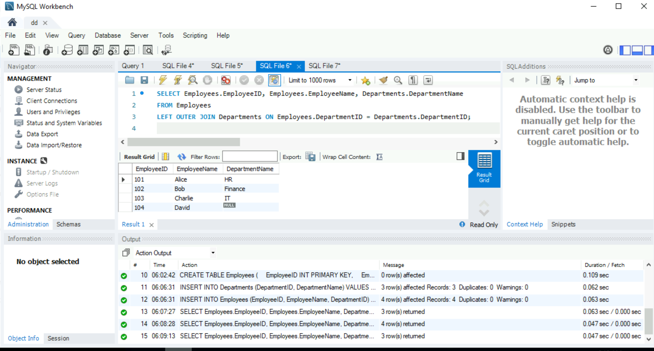

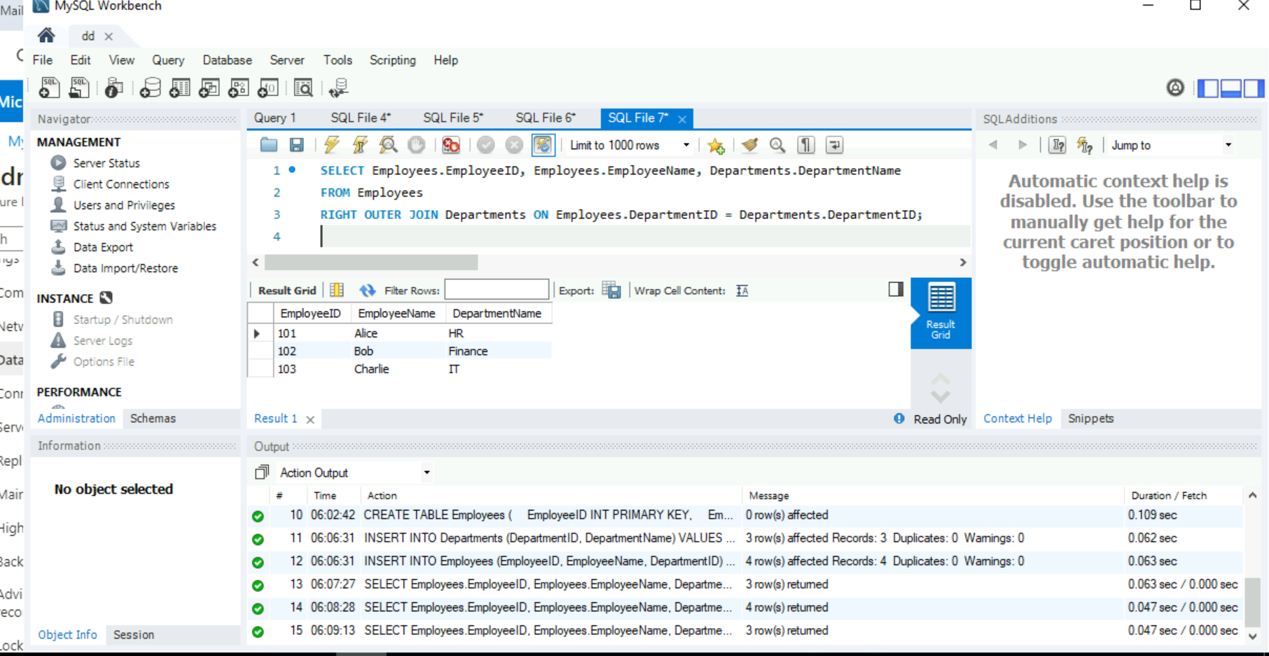

3) Host a jenkins image on azure container instance

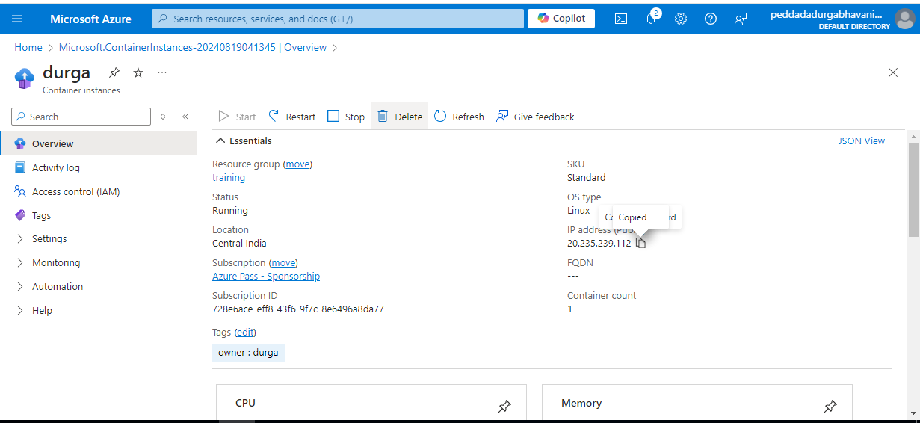

4) Create and Configure a Cosmos DB Account and demonstrate CRUD (Create, Read, Update, Delete) operations.

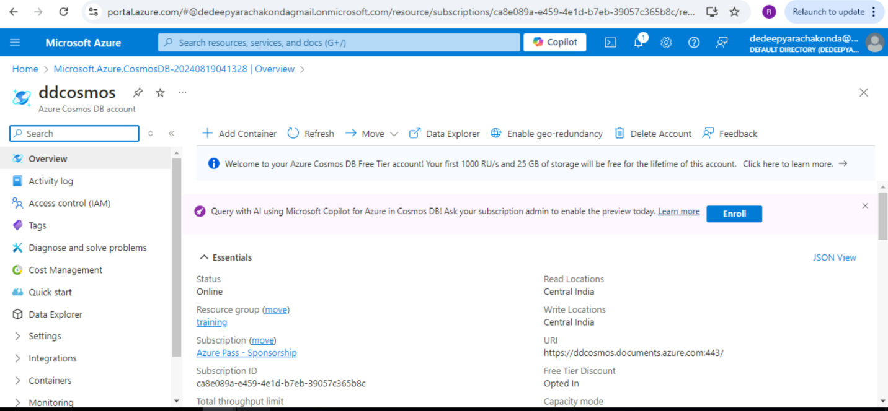

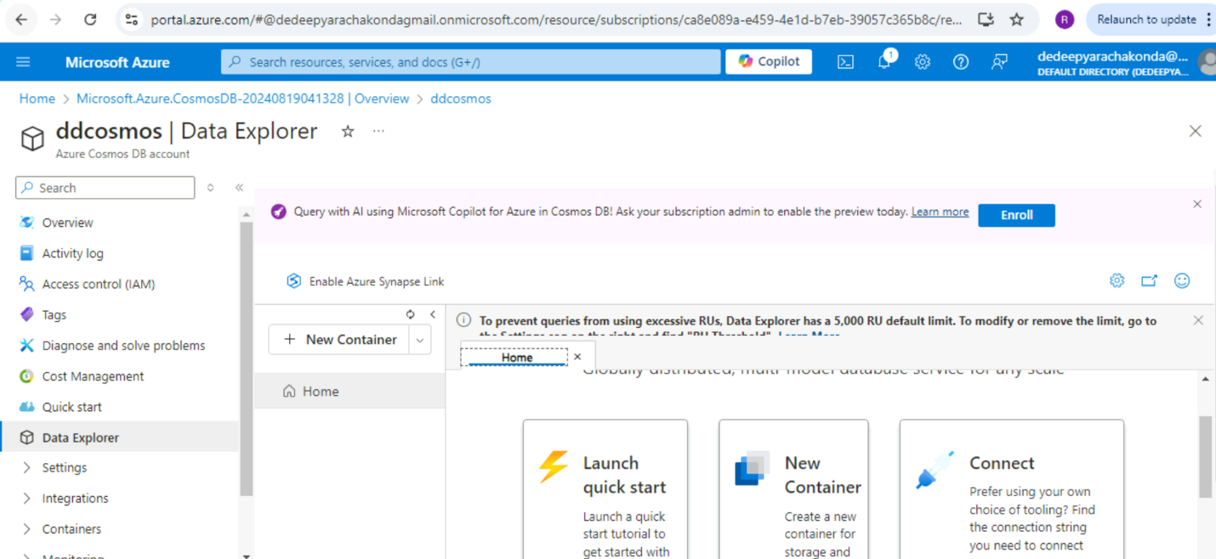

5) Create a alert for the high cpu usage with email notification on windows server



